Introduction to Geographic Information Systems (GIS)

Week 04

This week we will learn about filtering features. The GIS function is called “Selection by Attribute”. In order to do this, rather than use data that is provided, we will will download public data from the Internet, clean it up if necessary. We’ll continue to explore Education Data.

**Downloading data from the Internet**

For this exercise we will download Basemaps from the US Tigerline collection and Education Data for New York State Counties from the American Community Survey – a large collection of demographic data that can be analyzed from the national level down to the census tract (and much more).

***Downloading Basemaps***

1. Navigate to the US Census Tigerline Data website: <https://www.census.gov/geographies/mapping-files/time-series/geo/tiger-line-file.html>
2. Go to the *Web Interface* – near the bottom in green.
3. Select year: 2010
4. Select a layer type: *Counties and Equivalent*
5. In the second dropdown menu select New York – Select Download
6. Copy the downloaded file to your folder for this week and unzip
7. Start ArcMap and add the New York Counties shapefile.
8. Save the map in your week04 folder: *yourlastnameFemaleDoctorate*

***Downloading Demographic Data***

1. Navigate to the Census data website: <http://data.census.gov>
2. Select “Advanced Search”
3. We’ll set filters on the next page: Select “Search”
4. The default data based on the alphabetical name of the table comes up.
5. Select “Filter” at the top left (above “Tables”)
6. Select *Topics -> Education -> Educational Attainment*
7. Select *Geography -> County->New York->All Counties*
8. Select *Years->2010*
9. Select *Surveys->ACS 5-Year Estimates Detailed Tables*
10. Hide the selection screen (double down arrows on the top left)
11. Select *View All Tables* on the lower right
12. On the left, scroll to *Sex By Educational Attainment For The Population 25 Years And Over*
13. Select *Customize Table* on the upper right
14. Select *Download* from the options above the table
15. Make sure CSV and 2010 are checked
16. Select *Download* on the lower right ; after downloading, select *Download Now*
17. Place the downloaded file in your Week 04 folder and unzip
18. Note there are 3 files. One of *.csv* files is the data table and the other is metadata file. The *.txt* file is also metadata, but we won't need it.

***Cleaning the Data Spreadsheet***

1. ***Note. Each data field has 2 components:*** 
   1. ***Margin of error***
   2. ***Estimate***
2. ***We always want the Estimate. The Attribute Name ends in E***
3. To import into ArcMap it is necessary to clean the spreadsheet by eliminating extra rows and insuring that column names have no special characters (e.g. blanks). And limiting headings to 10 characters or less.
4. Open up the *.csv*  file with *data_with_overlays* in the name.
5. Remove Row 2 with the descriptions. They would be good to have, except that they are too long and have blanks.
6. Note that the column headings in the spreadsheet have 11 characters. Modify Row 1 by eliminating at least one character, keeping that last 4 or 5 characters (needed for reading the data dictionary). For example we can change B15002 to B1502. Highlighting the first row

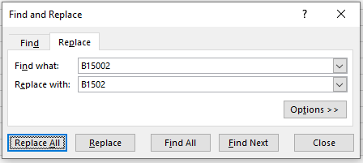

1. For a Join, the data in the columns to join (not the column name) must have matching entries. In the spreadsheet table, the *NAME* column includes the state name, but in the NYS Shapefile, the NAMELSAD10 column doesn’t. This means we have to remove the state name using the *replace* dialog in Excel. Higlighting Name column.
2. 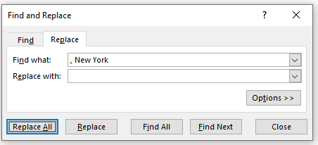
3. Save the file as *NYSEducationClean.csv*

***Join and create a shapefile with the joined data***

1. Go back to ArcMap and add Education .csv file.
2. Join the NYS Shape file with the table.

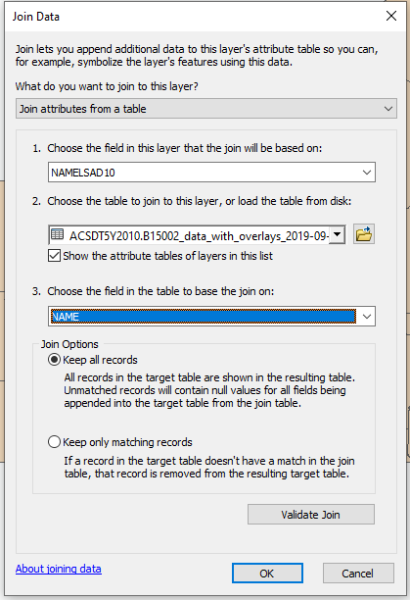

1. For some operations on the joined shapefile, we have to create a new shapefile that includes the join.
2. Right mouse-click the layer
3. Select Data ->Export Data
4. In the text box navigate to your folder and name the new shapefile *NYSEDucation.shp.*
5. Click OK
6. Select *Yes* to add layer to the map.
7. Check the attribute table of the new layer to see it contains the joined data.
8. Remove the table and the original joined layer (the tigerline basemap)
9. Save the map as: *NYSEducationMap01.mxd*

***Review: Create a color-coded Map***

1. The data is a little different than a previous shapefile. Create a color coded map for total females who have completed a doctoral degree.
2. Use the Metadata extract at the end of this document
3. Use the variable for *Estimate!!Total!!Female!!Doctorate degree* (Variable ends in E). I removed the Margin of Error values.
4. ***NOTE: the metadata file has B15002 that we change to B1502!!***
5. For the color-coded map right-click the layer -> Select Properties->select Symbology-> Select Quantities-> Graduated Colors.
6. Choose the encoded variable name and for “Normalization” choose the variable for the total number of degrees (Estimate!!Total)
7. In Display view, make sure the map is in Landscape and annotate the map: Background Color, Title, North Arrow, Legend, and Scale Bar
8. Export the map as a .jpeg: *yourlastnameNYSFemaleDoctorateColorCoded.jpg*
9. Save the map.

***Filtering: Selection by Attribute***

1. Start a new map.
2. From your week04 folder, add the shapefile we created: NYSEducation.shp. It contains the Counties basemap with joined education data.
3. Check the attribute table to make sure all the Education attributes are there.
4. Save the map as: NYSEducationMap02
5. We want to create 3 maps showing Counties with the of number of Females with different degrees and a map combining Males and Females with Associate degrees.
6. Make 2 copies of the Counties layer
   * 1. Right mouse click the layer (NYSEducation) and click copy.
     2. Right mouse click the "Layers" heading and paste the layer.
     3. Repeat the copy one more time
7. You should see 3 layers named NYSEducationDataJoined. Both new layers should have the Joined Education table. Rename them NYSFemaleBachelor, NYSFemaleMaster, NYSEducationMaleBachelorsMasters
8. Turn off the copies for now. We’ll use them later.

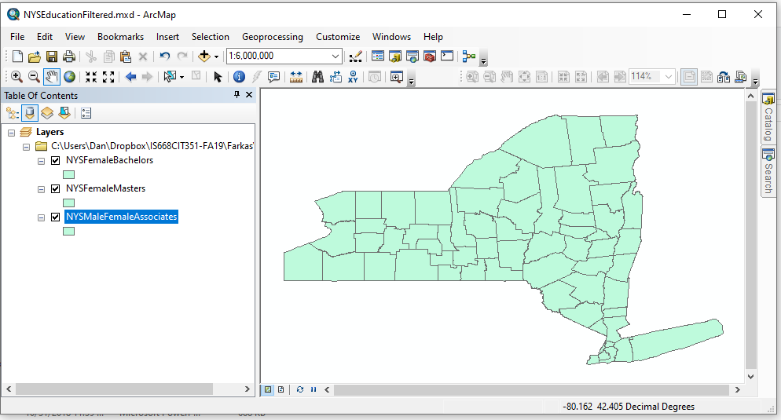

1. Check the Metadata file for the attribute name for:
   * 1. Female Bachelor 32E
     2. Female Masters 33E
2. Let's *select* the Counties Where the number of females with Bachelor degrees is low (<3000)
3. On the tool bar choose *Selection -> By Attribute*s
4. Make sure the proper layer in the top textbox is chosen (the renamed, joined layer
5. Choose the attribute B1502_032E, double click.  Notice it is placed in the textbox below.
6. Choose the logical operator "<".
7. Type in the value we want to be less than (3000)
8. Click ok.
9. Note that the map highlights those counties chosen in “blue”.
10. Save the map.
11. Open up the attributes table for this layer (right click on layer, open attribute table)
12. Note at the bottom to the left of the message that indicates how many have been selected are two icons. The left one shows all the features, the right one only those selected.
13. Click each one to see what happens. Close the attributes table
14. Note that the map highlights those counties chosen in “blue”.

**Creating a Selection Layer**

1. In order to work with the selected items we will want to create a layer of just the selected towns. This makes it permanent. We also may want to create a shapefile (we won’t do this now)
2. Right click the layer
3. Choose "Selection"
4. Chose the item: "Create a layer from selected features"
5. The new layer will be added to map, “NYSFemaleBachelors selection”
6. Rename it to something meaningful – “NYSFemaleBachelorsLess3000
7. Clear the selection now that we have the layer. On the top menu, choose Selection->Clear Selected Features
8. It might help to change the color of the new layer. Double-click the colored rectangle underneath the name of the new layer and choose a color that will stand out.
9. Toggle both the original and selection layers on and off - looking at the map of all the counties.
10. In Layout Mode, rename the Title to reflect the new map (e.g. NYS Female Bachelors < 3000).
11. NOTE. For titles, double click the title on the map and overwrite the first line (don’t worry about the special encoding, just overwrite it).
12. Add (Insert) Background color Legend, Scale Bar and a North Arrow.
13. With the new layer on, save the map.
14. Export the map image with the name *yourlastnameNYSFemaleBachelorsLess2000.jpg* in display view showing title, legend, north arrow and scale bar. Go back to data view.
15. For this map, create and submit (export) a pdf. Make sure the new selection layer and the original joined County layer are the only ones visible. Call it *yourlastnameNYSFemaleBachelorsLess3000.pdf.*  Only the layers that have been turned on will export to the PDF.
16. **NOTE. The selection layer is only in this map. If we want to create a shapefile (for use in other maps), we could export it as a shapefile.**
17. **NOTE: You will lose points if you don’t clear the selection**
18. **NOTE: You will lose points if you don’t have a legend**

**On your own**

1. Turn off all the layers except the first *copy,* NYSFemaleMasters
2. Similar to what we did for Bachelors, create a layer, using
   1. Selection by Attribute of counties with less than 1000 Females with Masters degrees. Check the Metadata for the name of the attribute (see last page).
   2. Select by attribute; right click layer;
   3. Create layer from selected features;
   4. Clear the selected features; rename the selection layer, *NYSFemaleMastersLess1000*;
   5. Make sure the color of the feature is distinguishable
3. In Layout View, re-title the map.
4. Export the map as a jpg with the name *yourlastnameNYSFemaleMastersLess1000.jpg* (File->Export Map)
5. Save the map

***Compound Selections***

Selections are not limited to a single attribute. Sometimes (maybe most times) we want to have multiple or combined selections. Suppose we want to find counties with low Bachelor degrees and low Masters degrees (so that Pace can open a campus and offer Masters degrees).

1. Turn off all the layers except the second *copy,* NYSMaleBachelorsMasters
2. Determine the Attribute names for Male Bachelors and Masters degrees
3. Create the compound Selection Query: "B1502_015E" < 3000 AND "B1502_016E" < 1000

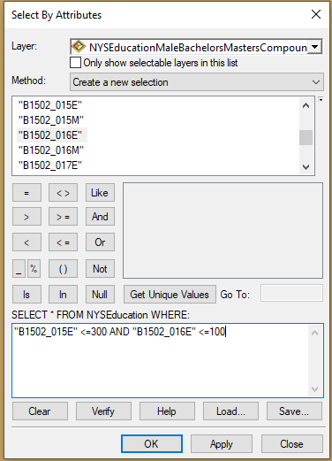

1. Create layer from selected features
2. Clear the selected features
3. Make sure the color of the feature is distinguishable
4. In Layout View, re-title the map.
5. Export the map as a jpg with the name *yourlastnameNYSMaleBachelorsMasters.jpg* (File->Export Map)
6. Save the map

**What is due this week (10/1/2019)**

1 word document with 4 jpgs:

*yourlastnameNYSFemaleDoctorateColorCoded.jpg*

*yourlastnameNYSFemaleBachelorsLess3000.jpg*

*yourlastnameNYSFemaleMastersLess1000.jpg*

*yourlastnameNYSMaleBachelorsMasters.jpg*

1 pdf

*yourlastnameNYSFemaleBachelorsLess3000.pdf*

Education Achievement Metadata

|  |  |
| --- | --- |
| GEO_ID | id |
| NAME | Geographic Area Name |
| B1502_001E | Estimate!!Total |
| B1502_002E | Estimate!!Total!!Male |
| B1502_003E | Estimate!!Total!!Male!!No schooling completed |
| B1502_004E | Estimate!!Total!!Male!!Nursery to 4th grade |
| B1502_005E | Estimate!!Total!!Male!!5th and 6th grade |
| B1502_006E | Estimate!!Total!!Male!!7th and 8th grade |
| B1502_007E | Estimate!!Total!!Male!!9th grade |
| B1502_008E | Estimate!!Total!!Male!!10th grade |
| B1502_009E | Estimate!!Total!!Male!!11th grade |
| B1502_010E | Estimate!!Total!!Male!!12th grade, no diploma |
| B1502_011E | Estimate!!Total!!Male!!High school graduate, GED, or alternative |
| B1502_012E | Estimate!!Total!!Male!!Some college, less than 1 year |
| B1502_013E | Estimate!!Total!!Male!!Some college, 1 or more years, no degree |
| B1502_014E | Estimate!!Total!!Male!!Associate's degree |
| B1502_015E | Estimate!!Total!!Male!!Bachelor's degree |
| B1502_016E | Estimate!!Total!!Male!!Master's degree |
| B1502_017E | Estimate!!Total!!Male!!Professional school degree |
| B1502_018E | Estimate!!Total!!Male!!Doctorate degree |
| B1502_019E | Estimate!!Total!!Female |
| B1502_020E | Estimate!!Total!!Female!!No schooling completed |
| B1502_021E | Estimate!!Total!!Female!!Nursery to 4th grade |
| B1502_022E | Estimate!!Total!!Female!!5th and 6th grade |
| B1502_023E | Estimate!!Total!!Female!!7th and 8th grade |
| B1502_024E | Estimate!!Total!!Female!!9th grade |
| B1502_025E | Estimate!!Total!!Female!!10th grade |
| B1502_026E | Estimate!!Total!!Female!!11th grade |
| B1502_027E | Estimate!!Total!!Female!!12th grade, no diploma |
| B1502_028E | Estimate!!Total!!Female!!High school graduate, GED, or alternative |
| B1502_029E | Estimate!!Total!!Female!!Some college, less than 1 year |
| B1502_030E | Estimate!!Total!!Female!!Some college, 1 or more years, no degree |
| B1502_031E | Estimate!!Total!!Female!!Associate's degree |
| B1502_032E | Estimate!!Total!!Female!!Bachelor's degree |
| B1502_033E | Estimate!!Total!!Female!!Master's degree |
| B1502_034E | Estimate!!Total!!Female!!Professional school degree |
| B1502_035E | Estimate!!Total!!Female!!Doctorate degree |